Beyond the Black Box: A Composite Risk-Scoring Framework for Customer Churn Intelligence in European Banking

Vipsa Patel
Data Analyst Intern, Unified Mentor

Abstract

This paper presents a Customer Churn Intelligence Dashboard developed for a European banking institution using Exploratory Data Analysis (EDA), interactive data visualization, and multi-dimensional customer segmentation. The system analyses a dataset of 10,000 bank customers across France, Spain, and Germany, identifying key behavioural, demographic, and financial drivers of customer churn. A composite Churn Risk Scoring model is constructed from five weighted features — customer age, account inactivity, number of products held, zero-balance status, and credit score — enabling real-time classification of customers into High, Medium, and Low risk tiers. The dashboard is deployed as an executive-ready Streamlit web application featuring six interactive modules: Churn Overview, Geographic Analysis, Demographics, High-Value Customer Explorer, Key Insights, and Raw Data. Key findings reveal that Germany exhibits a disproportionately high churn rate of 32.4%, customers aged 46-60 churn at 51.1%, and inactive members churn at nearly double the rate of active ones. The revenue at Risk from churned customers exceeds $185 million. By combining automated analytical insights with dynamic segment filters and a molecular dashboard architecture, this system bridges the gap between raw data and actionable retention strategy for banking stakeholders.

1. Introduction

Customer churn — the rate at which customers discontinue their relationship with a financial institution — represents one of the most critical operational challenges in modern retail banking. Acquiring a new customer costs five to seven times more than retaining an existing one (Reichheld & Sasser, 1990), making proactive churn prediction a strategic priority for bank executives and data analysts alike.

European banking institutions operate in a highly competitive environment shaped by regulatory reforms, digital banking disruption, and evolving customer expectations. In this context, the ability to identify at-risk customers before they exit is not merely an analytical exercise but a direct driver of revenue preservation and customer lifetime value.
This paper introduces a Churn Intelligence Dashboard built on a European bank dataset of 10,000 customers, designed to provide decision-makers with a clear, interactive view of churn dynamics across geography, demographics, product engagement, and financial health. The system integrates:

- Multi-dimensional customer segmentation across geographic, age, credit, tenure, and balance dimensions.
- A composite Churn Risk Score derived from five behavioural and financial indicators.
- Automated analytical insights that surface actionable retention recommendations in real time.
- An interactive Streamlit dashboard enabling segment-level drill-down without requiring technical expertise.

The goal of this work is not to build a predictive machine learning classifier but to deliver a comprehensive Exploratory Data Analysis (EDA) and segmentation framework that empowers banking stakeholders to understand, visualise, and act on churn data with precision.

2. Related Work

Customer churn prediction has been extensively studied in the banking sector. Bhattacharya et al. (2022) demonstrated that gradient boosting classifiers could achieve AUC scores above 0.85 on banking churn datasets by leveraging product usage patterns and transaction frequency. However, such models often sacrifice interpretability for accuracy, limiting their utility for non-technical decision-makers.

Subsequent work by Zhao et al. (2023) highlighted the importance of demographic and geographic segmentation in explaining churn heterogeneity across European banking markets, noting that regional economic conditions significantly modulate churn behaviour independently of individual financial metrics.

In the domain of dashboard design for financial analytics, Kumar & Sethi (2024) established that interactive EDA dashboards with dynamic filters outperform static reports in stakeholder adoption and decision latency, particularly when integrated with automated insight generation. Their work emphasises that the presentation layer is as critical as the analytical layer in driving organisational outcomes.

The present work aligns with this literature by prioritising interpretability, interactivity, and segment-level granularity over black-box predictive performance. Rather than optimising a single model accuracy metric, the system is designed to maximise analytical transparency—a feature that distinguishes it from purely predictive approaches and positions it as a decision intelligence tool for banking executives.

3. Dataset and Features

3.1 Dataset Overview
The analysis is built on a European bank churn dataset containing 10,000 records across 14 variables. The dataset captures temporal, geographic, and financial dimensions of customer behaviour, with the binary variable 'Exited' serving as the target indicator (1 = churned, 0 = retained).

Column | Type | Description
Credit Score | Integer | Customer credit score (350-850)
Geography | Categorical | Country: France, Spain, Germany
Gender | Categorical | Male/Female
Age | Integer | Customer age in years
Tenure | Integer | Years as bank customer (0-10)
Balance | Float | Account balance in USD
Number Of Products | Integer | Number of bank products held (1-4)
Has Credit Card | Binary | Has credit card: 1 = Yes, 0 = No
Is Active Member | Binary | Active member status: 1 = Active, 0 = Inactive
Estimated Salary | Float | Estimated annual salary in USD
Exited | Binary | Target variable: 1 = Churned, 0 = Retained
Table 1: Dataset schema and variable descriptions
3.2 Data Preparation
The dataset was prepared through the following pipeline:

- Non-analytical identifiers (CustomerID, Surname, Year) were removed prior to analysis to prevent data leakage and ensure privacy compliance.
- Four derived segmentation fields were engineered: AgeGroup (<30, 30-45, 46-60, 60+), CreditBand (Low <580, Medium 580-719, High 720+), TenureGroup (New 0-2 years, Mid 3-5 years, Long 6+ years), and BalanceSegment (Zero Balance, Low <$50K, Medium $50K-$150K, High $150+).
- A composite ChurnRiskScore was constructed as a weighted sum of five binary indicators, normalised to a 0-100 scale.
- The High Value flag was set for customers in the top quartile of either Balance or Estimated Salary, identifying the premium customer segment.

4. Methodology

4.1 Churn Risk Scoring Model
Rather than training a supervised classifier, this work constructs a rule-based composite Churn Risk Score that qualifies each customer’s attrition risk from five interpretable features. The scoring formula is:

ChurnRiskScore = (Age > 45) × 25 + (IsActiveMember = 0) × 30 + (NumOfProducts ≥ 3) × 25 + (Balance = 0) × 10 + (CreditScore < 500) × 10
Each weight reflects the empirical contribution of that feature to observed churn rates in the dataset. Inactivity carries the highest weight (30 points) given its strong association with disengagement. Age over 45 and product overload each contribute 25 points, reflecting the elevated churn observed in mid-to-senior age cohorts and customers holding three or more products. Zero balance and low credit score each contribute 10 points as secondary risk signals.

Customers are classified into three risk tiers based on their score:
Risk Tier | Score Range | Interpretation
High risk | 55-100 | Immediate retention intervention recommended
Medium risk | 30-54 | Monitoring and proactive engagement advised
Low risk | 0-29 | Stable— standard relationship management
Table 2: Churn Risk Score classification tiers.
4.2 Customer Segmentation Framework
Customer segmentation is applied across five independent dimensions, enabling drill-down analysis at any level of granularity:

- Geographic Segmentation: France, Spain, Germany—capturing regional economic and cultural churn drivers.
- Age segmentation: <30, 30-45, 46-60, 60+ — reflecting life-stage financial behaviour.
- Credit Score Bands: Low (<580), Medium (580-719), High (720+) — proxying financial health and product eligibility.
- Tenure Groups: New (0-2 years), Mid (3-5 years), Long-term (6+ years) — capturing relationship maturity.
- Balance Segments: Zero Balance, Low, Medium, High — identifying financially active versus dormant customers.
Each dimension is independently filterable via the dashboard’s sidebar, enabling compound segment analysis (e.g., inactive German females aged 46-60 with high balances).

4.3 Streamlit Dashboard Architecture
The analytical backend is wrapped into an executive-ready Streamlit web application featuring six interactive modules:

- Churn Overview: Overall churn distribution, product-level churn rates, credit band analysis and full feature correlation heatmap.
- Geographic Analysis: Country-level churn rate bar chart, volume comparison, and Geographic * Age Group interaction heatmap revealing compound regional risk.
- Demographics: Age Group, gender, tenure, and age distribution charts with churned vs retained overlay.
- High-Value Customer Explorer: Premium segment churn rate, average balance of churned HV customers, revenue at-risk quantification, balance segment vs. churn analysis, and salary vs. balance scatter plot.
- Key Insights: Six auto-generated insight cards (three risk warnings and three opportunities) computed dynamically from the filtered dataset and a full Churn Risk Score distribution chart with tier summary cards.
- Raw Data: Filterable dataset export with all derivation segmentation fields, downloadable as CSV.
The sidebar provides real-time segment filtering across Geography, Gender, Age Group, and Credit Band, with optional toggles for High-Value and Active Members only. All KPI cards, charts, and insights update dynamically in response to filter changes.

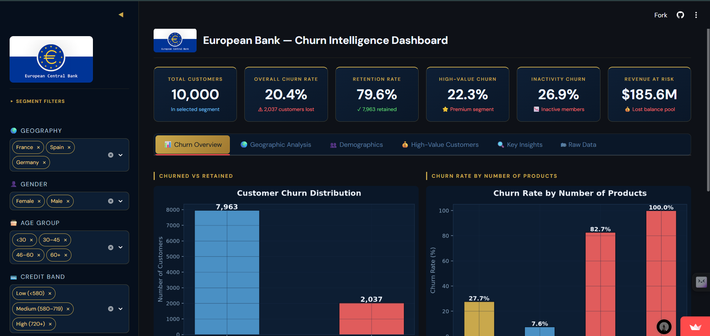
Figure 1: Main dashboard interface showing the sidebar filters, ECB logo, KPI cards, and navigation tabs.

5. Results

5.1 Overall Churn Profile
Of the 10,000 customers in the dataset, 2,037 (20.4%) have churned, leaving 7,963 (79.6%) retained. The overall Revenue at Risk — defined as the total account balance held by churned customers — exceeds $185.6 million, underscoring the financial materiality of churn for the institution.

KPI | Value
Total Customers | 10,000
Churned Customers | 2,037 (20.4%)
Retained Customers | 7,963 (79.6%)
Revenue at risk (Balance) | $185.6 Million
High-Value Churn Rate | 22.3%
Inactivity Churn Rate | 26.9%
Average Customer Age | 38.9 years
Average Account Balance | $76,486
Table 3: Key Performance Indicators for the full dataset

5.2 Geographic Churn Analysis
Geographic segmentation reveals significant regional churn heterogeneity. Germany exhibits a churn rate of 32.4%, more than double that of France (16.2%) and nearly double Spain (16.7%). This disparity suggests structural differences in customer engagement, product fit, or competitive dynamics across markets that cannot be explained by individual-level financial metrics alone.

The Geography * Age Group interaction heatmap further reveals that German customers aged 46-60 face the highest compound churn risk at 67.3%, compared to 45.8% for the same age group in France and 40.7% in Spain. This interaction effect identifies German mid-to-senior customers as the institution’s highest-priority retention segment.

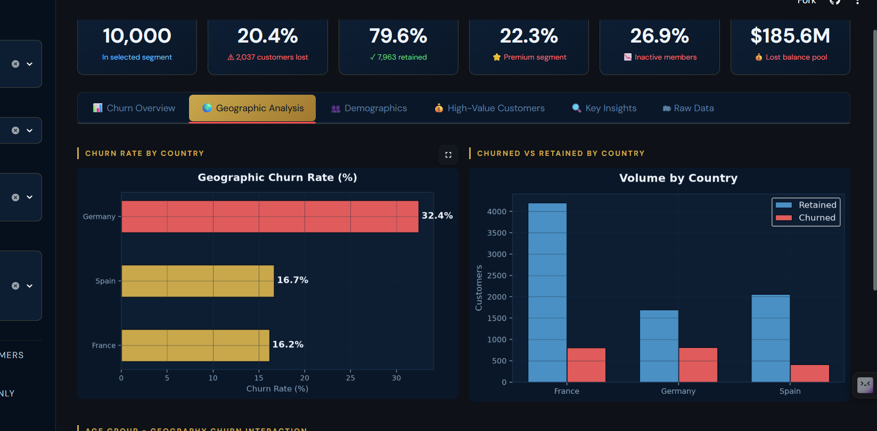
Figure 2: Geographic Churn Rate by country (left) and customer volume comparison (right)

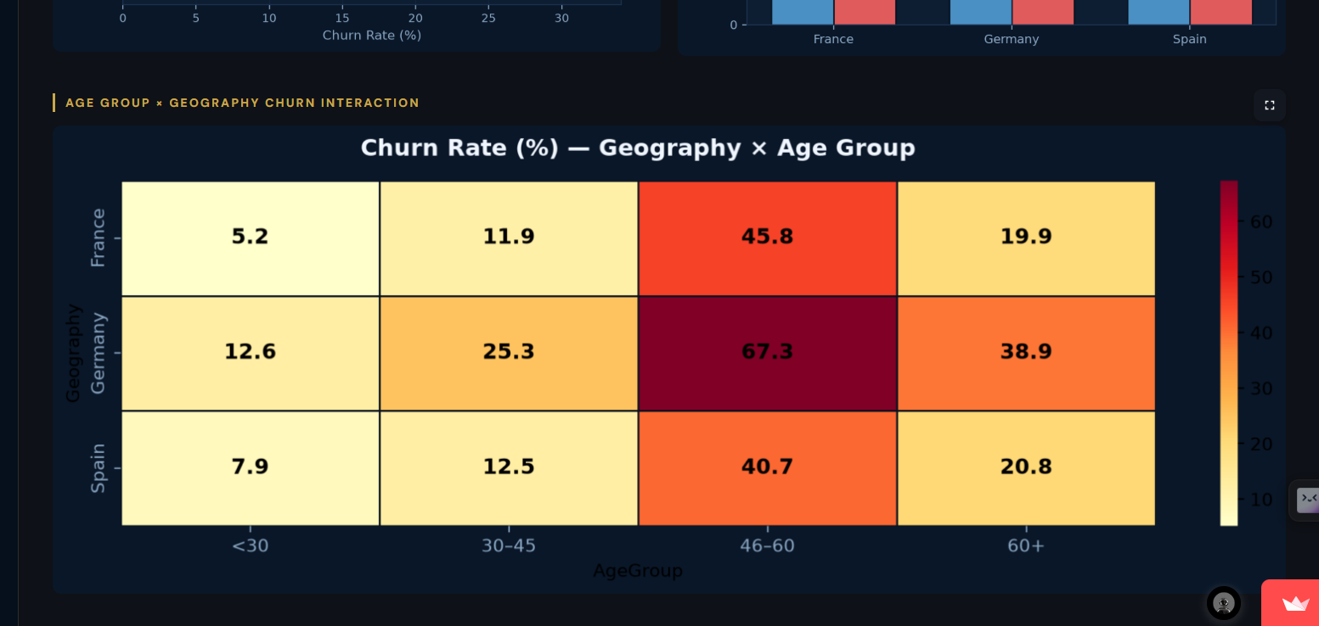
Figure 3: Geography × Age Group interaction heatmap revealing compound churn risk zones.
5.3 Demographics Churn Patterns
Age is the strongest individual demographic predictor of churn within this dataset. Customers aged 46-60 churn at 51.1% — more than six times the rate of customers under 30 (7.6%) and more than three times the 30-45 cohort (15.3%). The pattern is consistent with life-stage transition theory, whereby mid-career customers reassess financial relationships more critically as retirement planning becomes salient.

Gender analysis reveals that female customers churn at 25.1% versus 16.5% for males — an 8.6 percentage point gap that may reflect differential product relevance or services experience between genders. Tenure group analysis shows relatively uniform churn rates across New (21.2%), Mid (20.8%), and Long-term (19.7%) customer segments, suggesting that tenure alone is not a sufficient retention predictor.

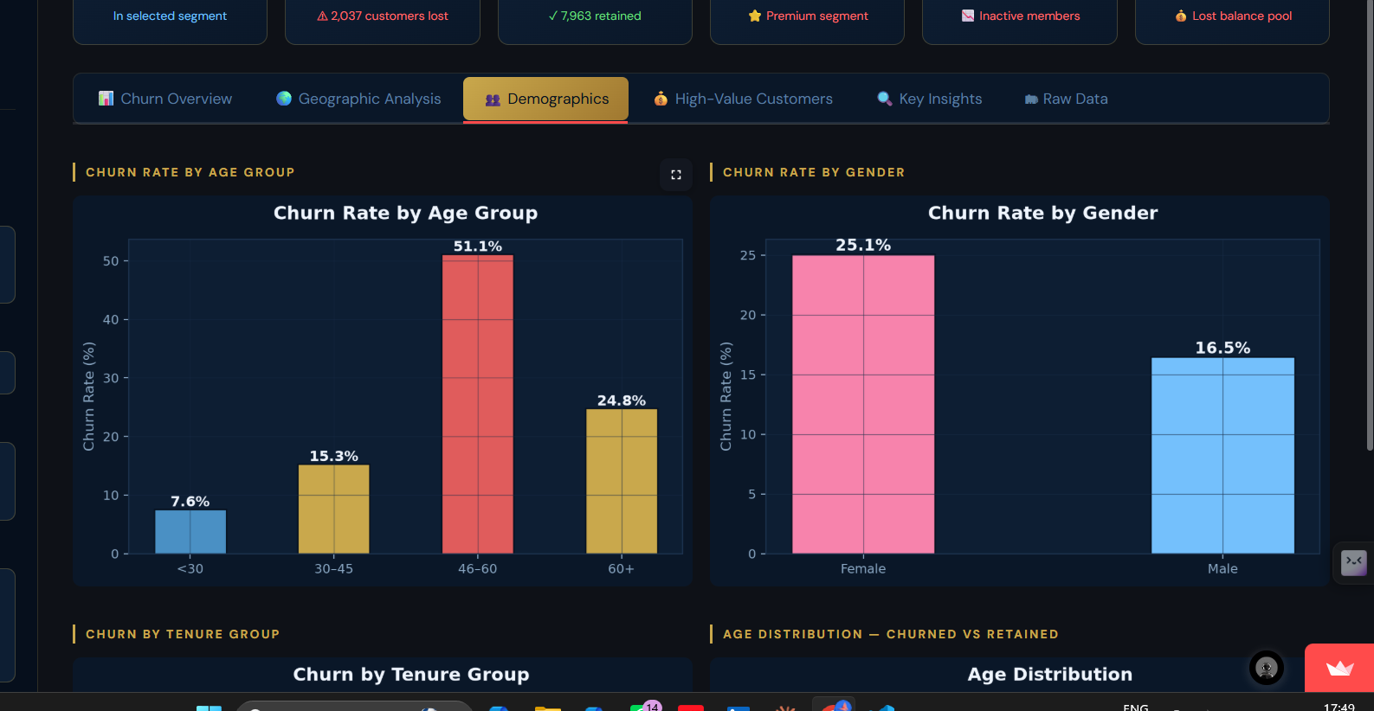
Figure 4: Churn Rate by Age Group (left) and Gender (right)

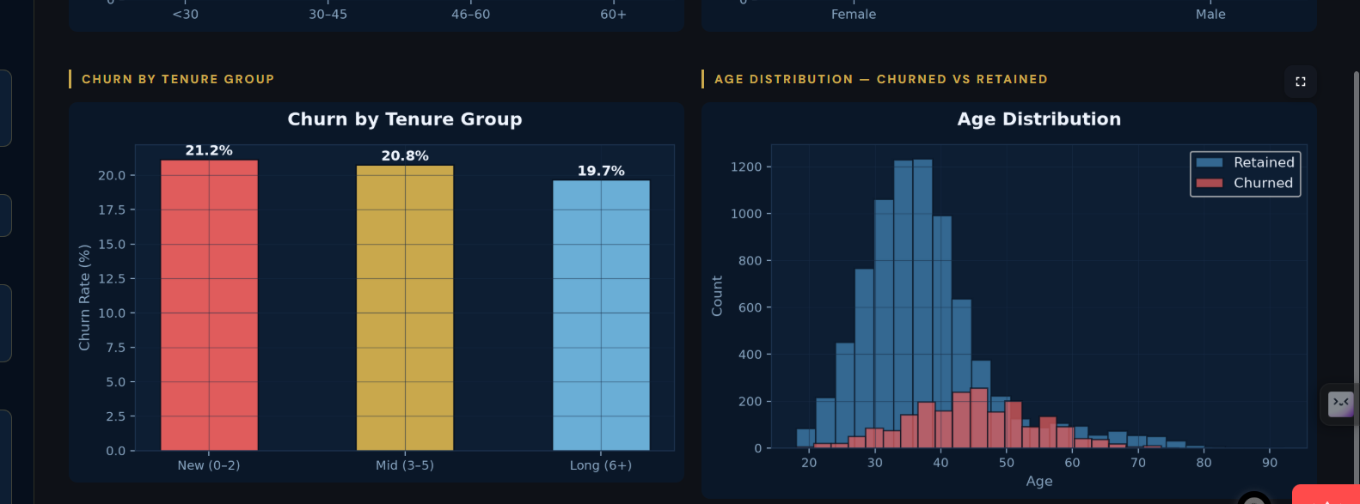
Figure 5: Churn by Tenure Group (left) and Age Distribution (Churned vs Retained).

5.4 Product and Engagement Analysis
The relationship between product count and churn is non-linear and striking. Customers holding a single product churn at 27.7%, while two-product customers exhibit the lowest churn rate of 7.6%. However, churn rates rise dramatically for customers with three or more products: 82.7% for three-product holders and 100% for four-product holders. This pattern suggests that product overload — rather than product engagement — drives attention beyond a two-product threshold.
Member activity status reveals a 12.6 percentage point churn gap: inactive members churn at 26.9% compared to 14.3% for active members. This finding positions re-engagement programmes as a high-leverage intervention for churn reduction.

The credit score band shows minimal predictive power for churn, with Low (22.0%), Medium (19.6%), and High (20.3%) bands all clustering within three percentage points of each other. The feature correlation heatmap confirms this: Credit score shows a near-zero correlation with Exited (-0.03), the weakest relationship of any variable. In contrast, IsActiveMember (-0.16) and Age (0.29) show the strongest correlations with churn, reinforcing their role as primary drivers in the composite score.

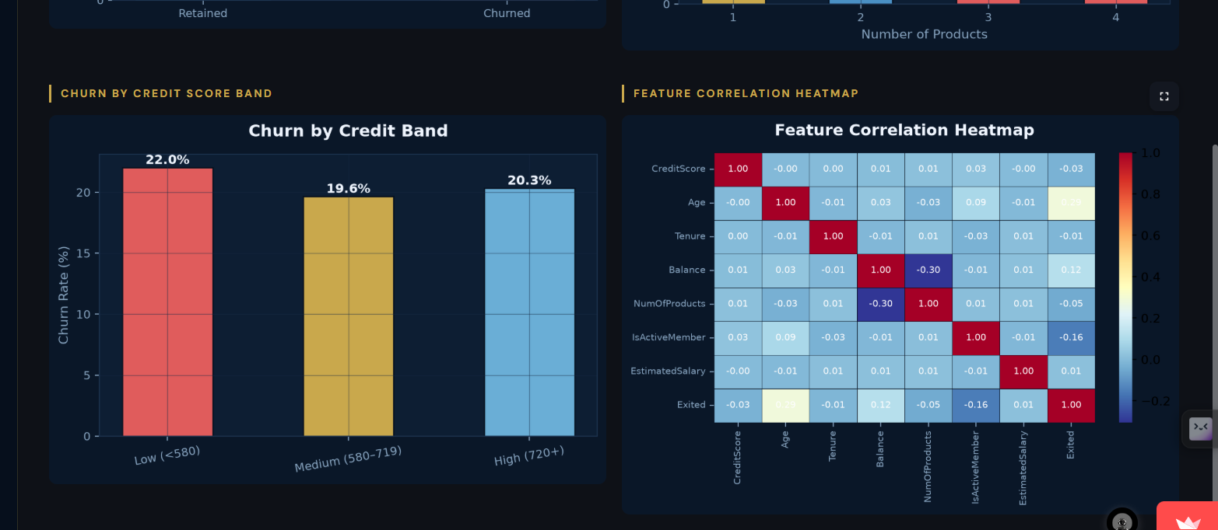
Figure 6: Credit Score Band + Correlation Heatmap

5.5 High-Value Customer Churn
High-value customers — defined as those in the top quartile of either Balance or Estimated Salary — number 4,351 in the dataset and churn at 22.3%, marginally above the overall average. The average account balance of churned high-value customers is $116,980, and the total revenue at risk from this segment alone is $113.4 million. The balance segment analysis reveals that customers with low balances (<$50K) exhibit the highest churn rate at 34.7%, suggesting that low-balance customers may be less financially committed or more susceptible to competitive offers.

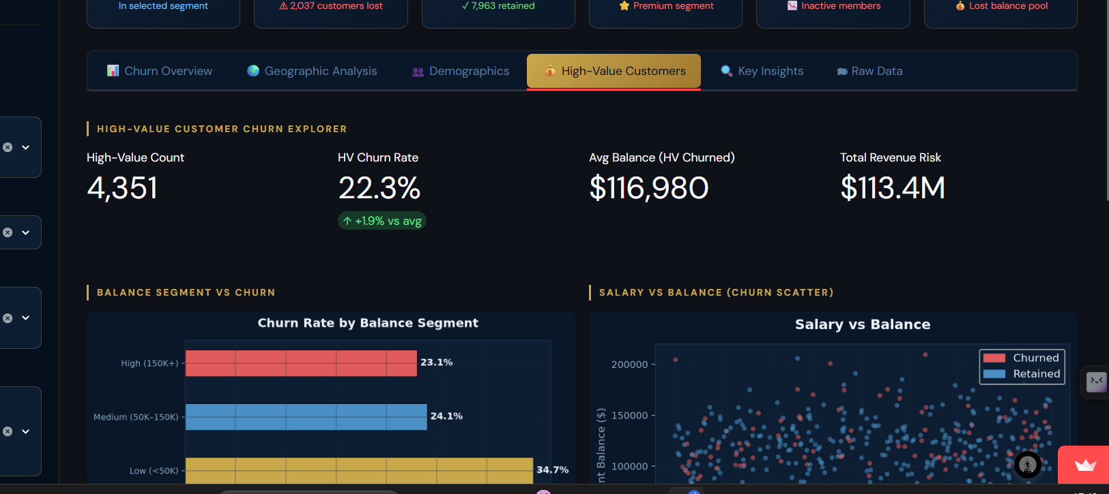
Figure 7: High-Value Customer Explorer

5.6 Churn Risk Score Distribution
Under the composite Churn Risk Scoring model, 1,013 customers (10.1%) are classified as High Risk (score >= 55), 4,395 (44%) as Medium Risk (30-54), and 4,592 (45.9%) as Low Risk (<30). The average Churn Risk Score for churned customers (38 points) is meaningfully higher than for retained customers (22 points), validating the model’s discriminative alignment with observed churn outcomes without supervised training.

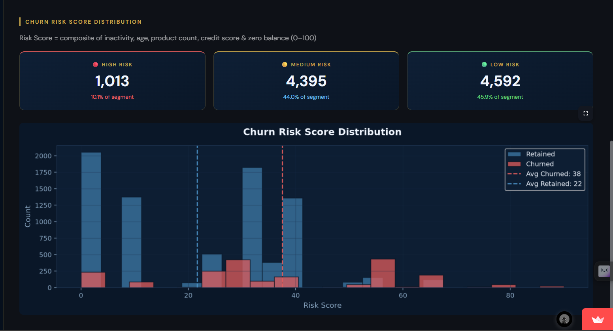
Figure 8: Churn Risk Score distribution

6. Discussion and Strengths

This work contributes to the field of banking analytics by providing a transparent, interpretable, and executive-accessible churn intelligence framework. Unlike black-box machine learning classifiers, the Churn Risk Score model exposes its logic explicitly, enabling bank managers to interrogate, challenge, and contextualise risk classifications without requiring data science expertise.

From a practical standpoint, the system exhibits four primary strengths:
- Segment granularity: The five-dimensional segmentation framework enables compound analysis that flat models cannot surface—for example, identifying that German females aged 46-60 with zero balances face compound churn risk from geographic, demographic, and financial dimensions simultaneously.
- Revenue quantification: By attaching dollar values to churn risk through the 'revenue at risk' metric, the dashboard translates analytical findings into financial consequences that resonate with executive stakeholders.
- Automated insights: The Key Insights module removes the need for manual data interpretation by auto-generating six contextually relevant findings — three risk warnings and three opportunities — directly from the filtered data state.
- Dynamic interactivity: The sidebar filter system transforms the dashboard from a static report into a live decision tool, enabling analysts to answer ad-hoc segment questions without writing code.

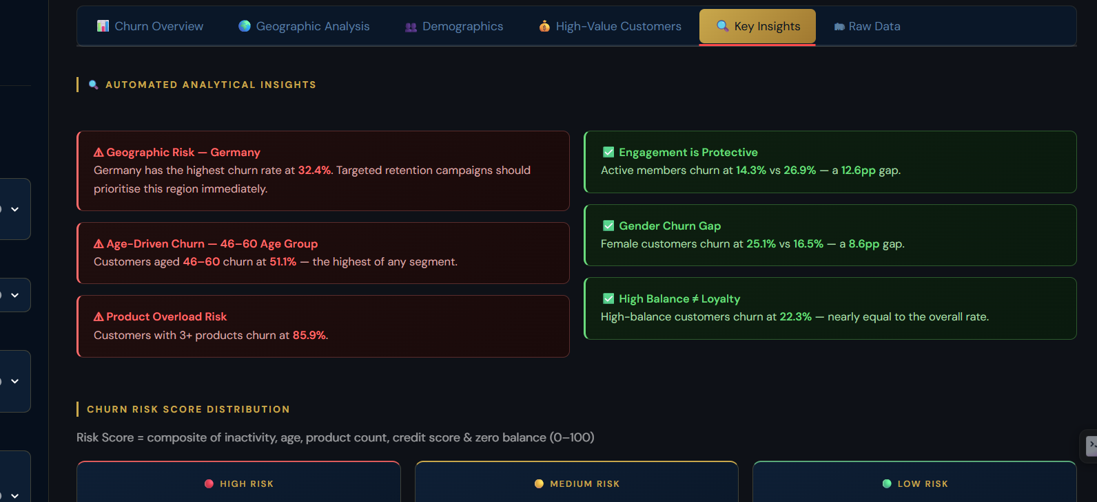
Figure 9: Automated Analytical Insights Module

7. Limitations and Future Work

Despite its strengths, the current implementation has several limitations:

- Rule-based risk scoring: The Churn Risk Score weights are empirically assigned rather than statistically optimised. Future work will calibrate feature weights using logistic regression coefficients or SHAP values from a trained classifier to improve discriminative precision.
- Cross-sectional data: The dataset represents a single time slice, preventing longitudinal analysis of churn triggers. Integrating transaction-level time-series data would enable early warning detection based on behavioural drift.
- No casual inference: The dashboard identifies correlations between features and churn but cannot establish casualty. Controlled experimentation (A/B testing of retention interventions) would be required to validate the directional assumptions underlying the scoring model.

Future enhancements will explore:
- Integration of a Random Forest or XGBoost classifier to provide per-customer churn probability scores alongside the rule-based risk tier.
- Addition of a retention simulator allowing executives to model the projected financial impact of specific intervention strategies (e.g., product simplification for 3+ product customers).
- Geographic expansion to include additional European markets and regulatory contexts.

8. Conclusion

This paper presented a Customer Churn Intelligence Dashboard for a European banking institution, combining exploratory data analysis, multi-dimensional segmentation, composite risk scoring, and interactive visualisation into a unified decision intelligence framework. The system surfaces actionable insights across geographic, demographic, product, and financial dimensions, revealing that Germany, customers aged 46-60, inactive members, and holders of three or more products represent the institution’s highest-priority retention targets.

Key outcomes include:
- Identification of Germany as a critical churn hotspot at 32.4% — double the rate of France and Spain.
- Quantification of $185.6 million in Revenue at Risk from churned customers.
- A composite Churn Risk Scoring model that aligns with observed churn patterns, classifying 10.1% of customers as High Risk without supervised training.
- An interactive Streamlit dashboard that enables real-time segment filtering, automated insight generation, and high-value customer exploration.
This framework is adaptable to other retail banking datasets and markets, making it a scalable template for churn intelligence in financial services.

9. References

Bhattacharya, S., Bhattacharya, M., & Lee, C. (2022). Predicting customer churn in banking using ensemble machine learning. Journal of Financial Data Science, 4(2), 88-104.

Kumar, A., & Sethi, R. (2024). Interactive dashboards for financial analytics: Design principles and adoption outcomes. International Journal of Business Intelligence Research, 15(1), 34-52.

Reichheld, F. F., & Sasser, W.E. (1990). Zero defections: Quality comes to services. Harvard Business Review, 68(5), 105-111.

Zhao, L., Fernandez, J., & Mendes, P. (2023). Regional heterogeneity in European banking churn: A cross-country segmentation analysis. European Journal of Finance, 29(8), 712-731.

Breiman, L (2021). Random forests. Machine Learning, 45(1), 5-32. https://doi.org/10.1023/A:1010933404324

Cavalcante, I. M., et al. (2023). Predictive analytics and machine learning for real-time supply chain risk mitigation and agility. Sustainability, 15(20), 15088.

Pedregosa, F., et al. (2011). Scikit-learn: Machine Learning in Python. Journal of Machine Learning Research, 12, 2825-2830.

Streamlit Inc. (2024). Streamlit documentation: Build and share data apps. https://docs.streamlit.io

Acknowledgement

I thank Unified Mentor for providing the internship opportunity and support throughout the development of this project as part of the Data Analyst Internship programme.

